ReactJS Hands-on Lab - TrainersApp

Commands Used
- npx create-react-app trainersapp
- cd trainersapp
- npm install react-router-dom@6
- npm start

Project Structure

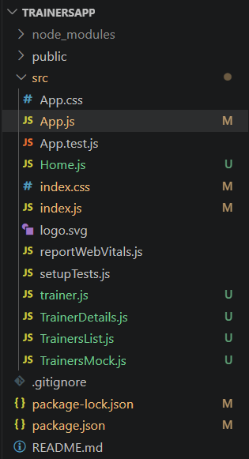

trainer.js
class Trainer {
constructor(trainerId, name, email, phone, technology, skills) {
this.trainerId = trainerId;
this.name = name;
this.email = email;
this.phone = phone;
this.technology = technology;
this.skills = skills;
}
}
export default Trainer;

TrainersMock.js
import Trainer from "./trainer";
const trainersMock = [
new Trainer("t-syed","Syed Khaleelullah","khaleelullah@cognizant.com","97676516962",".NET",
["C#","SQL Server","React",".NET Core"]),
new Trainer("t-jojo","Jojo Jose","jojo@cognizant.com","9897199231","Java",
["Java","JSP","Angular","Spring"]),
new Trainer("t-elisa","Elisa Jones","elisa@cognizant.com","9871212235","Python",
["Python","Django","Angular"])
];
export default trainersMock;

Home.js
function Home() {
return (
<div>
<h2>Welcome to My Academy trainers page</h2>
</div>
);
}
export default Home;

TrainersList.js
import trainersMock from "./TrainersMock";
import { Link } from "react-router-dom";
function TrainersList() {
return (
<div>
<h2>Trainers List</h2>
<ul>
{trainersMock.map((trainer) => (
<li key={trainer.trainerId}>
<Link to={`/trainer/${trainer.trainerId}`}>
{trainer.name}
</Link>
</li>
))}
</ul>
</div>
);
}
export default TrainersList;

TrainerDetails.js
import { useParams } from "react-router-dom";
import trainersMock from "./TrainersMock";
function TrainerDetails() {
const { id } = useParams();
const trainer = trainersMock.find((t) => t.trainerId === id);
if (!trainer) {
return <h2>Trainer Not Found</h2>;
}
return (
<div>
<h2>Trainers Details</h2>
<h3>{trainer.name} ({trainer.technology})</h3>
<p>{trainer.email}</p>
<p>{trainer.phone}</p>
<ul>
{trainer.skills.map((skill,index)=>(
<li key={index}>{skill}</li>
))}
</ul>
</div>
);
}
export default TrainerDetails;

App.js
import {
BrowserRouter,
Routes,
Route,
Link,
Navigate
} from "react-router-dom";
import Home from "./Home";
import TrainersList from "./TrainersList";
import TrainerDetails from "./TrainerDetails";
function App() {
return (
<BrowserRouter>
<h1>My Academy Trainers App</h1>
<Link to="/home">Home</Link>
{" | "}
<Link to="/trainers">Show Trainers</Link>
<hr />
<Routes>
<Route path="/" element={<Navigate to="/home" replace />} />
<Route path="/home" element={<Home />} />
<Route path="/trainers" element={<TrainersList />} />
<Route path="/trainer/:id" element={<TrainerDetails />} />
</Routes>
</BrowserRouter>
);
}
export default App;

index.js
import React from "react";
import ReactDOM from "react-dom/client";
import "./index.css";
import App from "./App";
const root = ReactDOM.createRoot(document.getElementById("root"));
root.render(
<React.StrictMode>
<App />
</React.StrictMode>
);

index.css
body{
font-family: Arial;
margin:30px;
}
a{
margin-right:10px;
}
ul{
padding-left:20px;
}

Console Output
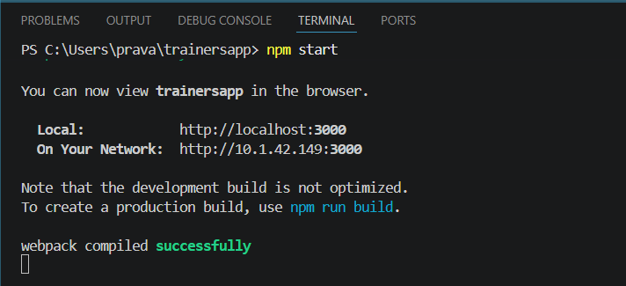
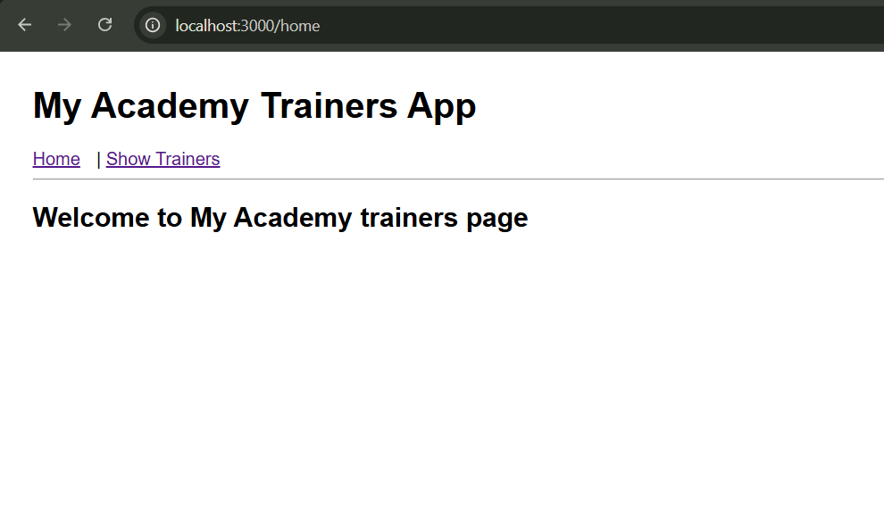
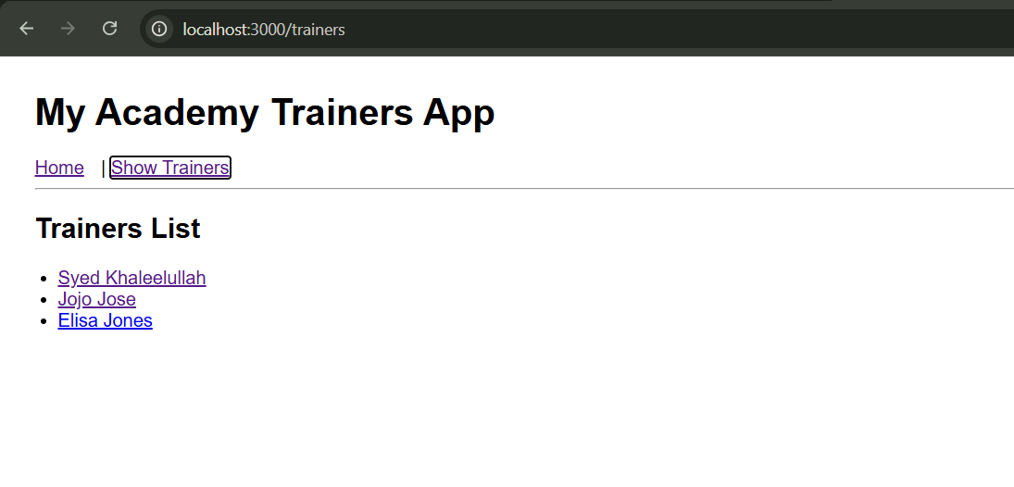
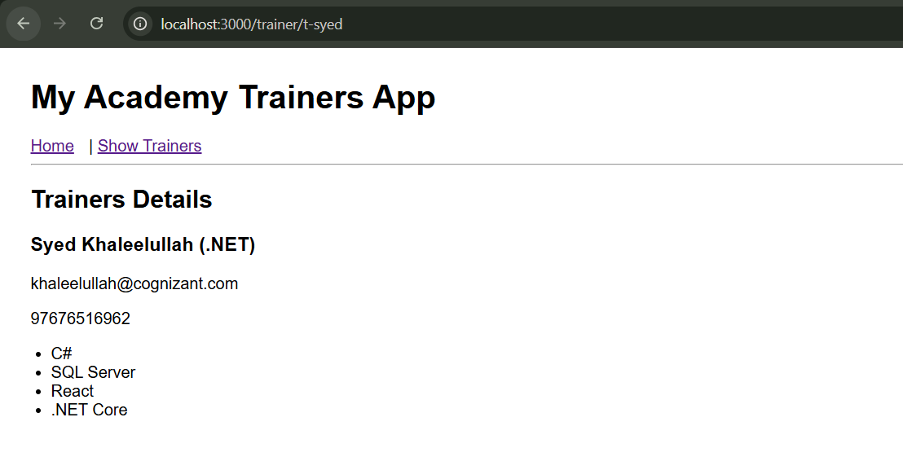

Conclusion
The React Router application was implemented successfully. Navigation between Home, Trainers List, and Trainer Details works correctly using BrowserRouter, Routes, Route, Link, Navigate, and useParams().

